Task 2: EC2 Static Website Hosting
Terminal Commands :
sudo yum update -y
sudo dnf install nginx -y
sudo systemctl start nginx
sudo systemctl enable nginx
cd /usr/share/nginx/html/
sudo rm -f index.html
sudo nano index.html
STEPS -
- Launch EC2 instance (t2.micro) in a public subnet.
- SSH into EC2 instance.
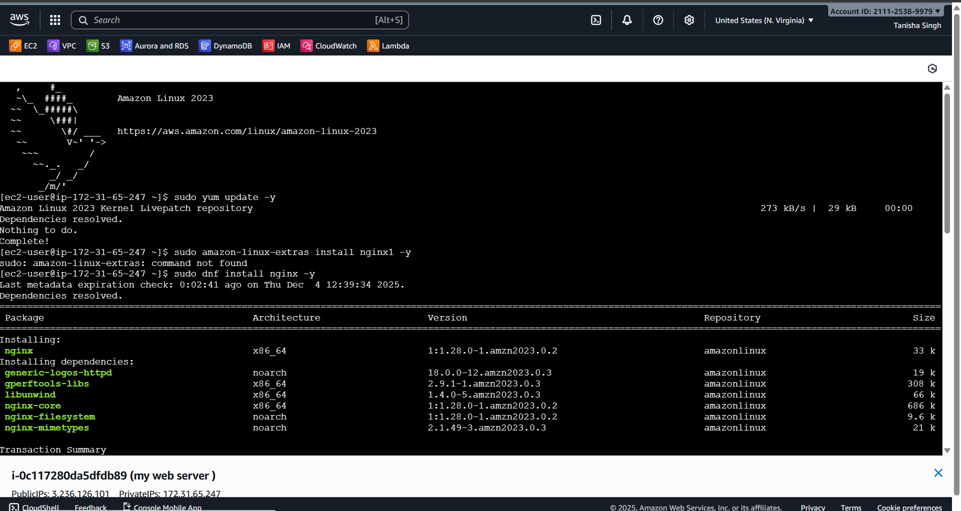
- Install Nginx.
- Upload static resume files to /var/www/html.
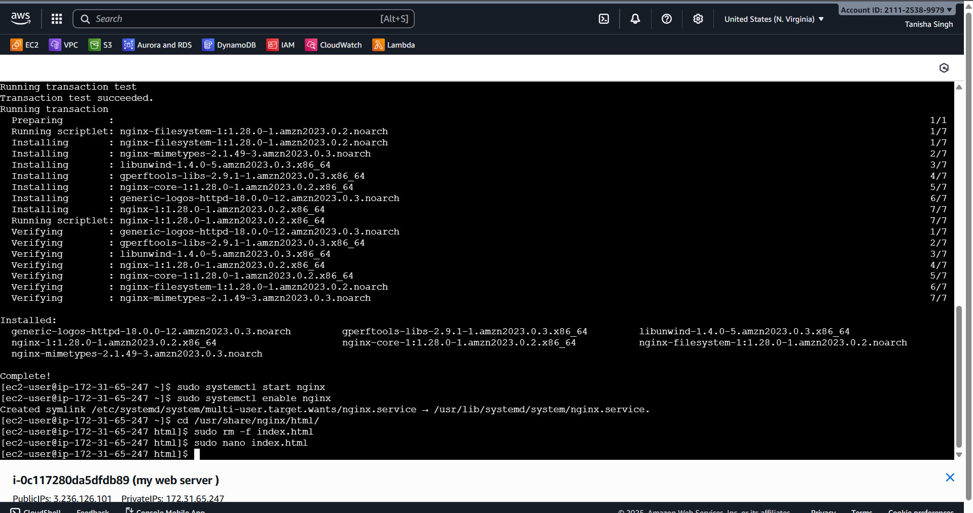
- Access the website in browser using EC2 public IP.
